DATA ANALYTICS

ASSIGNMENT 4

Extract Transform and Load

TEAM MEMBERS

NAME SRN  
VIMARSHA R PES1201701590

VINUTHA M N PES1201701373

KEERTHI PRIYA P PES1201701643

Extract,Transform and Load :

ETL is defined as a process that extracts the data from different RDBMS source systems, then transforms the data (like applying calculations, concatenations, etc.) and finally loads the data into the Data Warehouse system. ETL full-form is Extract, Transform and Load.

## Why do you need ETL?

* ETL provides a method of moving the data from various sources into a data warehouse.
* It helps companies to analyze their business data for taking critical business decisions.
* Transactional databases cannot answer complex business questions that can be answered by ETL.

*ETL PROCESS:*

**1) Extraction:**

In this step, data is extracted from the source system into the staging area.

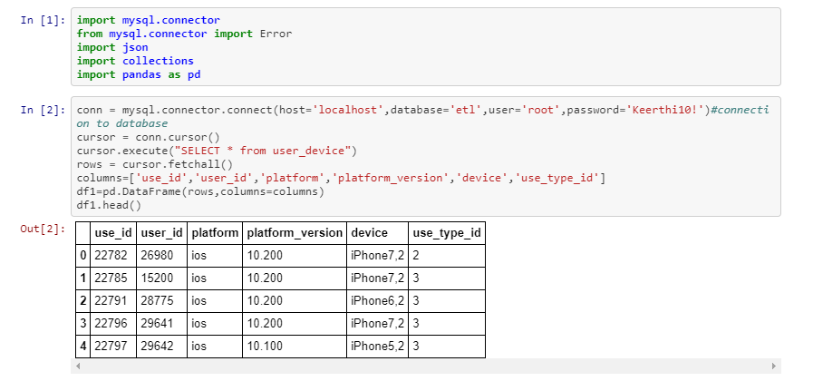

**2) Transform:**

Data extracted from source server is raw and not usable in its original form. Therefore it needs to be cleansed, mapped and transformed.

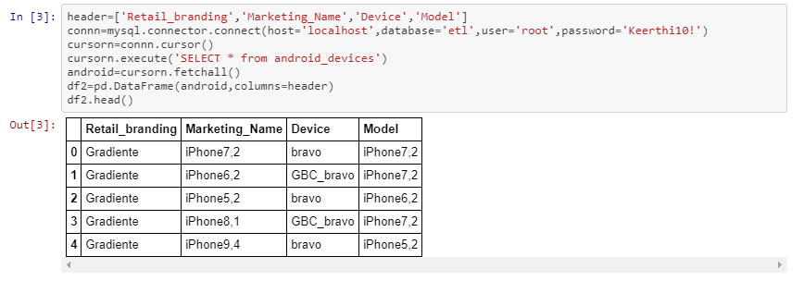

**3) LOAD:**

Loading data into the target datawarehouse database is the last step of the ETL process.

